Article title should be less than 15 words, no acronyms

K.J. Palmer,1,[1]a A. Simonis,1,2 C. Holm-Weaver, K. Burger, S. Rankin2

1 Department1, University1, City, State Zip Code, Country

2 Department2, University2, City, State Zip Code, Country

[author.one@universityone.edu](mailto:author.one@universityone.edu), [author.two@universityone.edu](mailto:author.two@universityone.edu), [author.three@universitytwo.edu](mailto:author.three@universitytwo.edu)

Understanding the spatial and temporal extent and context of sound levels is of increasing interest in the bioacoustics field. Spatial analysis of ambient noise is usually done using costly large scale arrays or through a combination of single sensors and propagation models. This work presents a method for mapping sound variation in environmental sound level using drifting hydrophones within the MRSea framework. This method is well suited for low frequency analysis relative to the ensemble aperture. We present the findings and limitations of this work and propose analysis and deployment modifications to meet a variety of needs.

1. Introduction and first-level headings

Understanding and reporting ambient noise levels is a crucial part of all passive acoustic studies. Ambient noise levels can influence local marine life, sometimes adversely, and introduce bias into density, abundance, or occupancy estimates (Oedekoven et al. 2022, Palmer et al. 2022). Within the context of BOEMs wind energy areas (WEA), there is a concerted effort to understand whether and how ambient noise levels change between the baseline, construction, and operational phases of offshore wind farms and how this may affect different. These baseline data are critical to monitor changes in sound levels from anthropogenic sources in space and time as activities related to offshore wind development commence (Gabriel et al. 2018).

In creating sound level metrics, it is important to consider that levels vary as a function of three-dimensional location as well as time (Choelwiak et. al 2018, ZoBell et al 2024). As the goal of many bioacoustics studies is to measure soundscape changes as they relate to species of interest, it is important to measure sound levels within the habitat they utilize or estimate it based on local measurements. For example, in deep-water environment measurements obtained from bottom mounted hydrophones may be representative of the foraging habitat of deep diving, species but may not be representative of the habitat occupied by mesopelagic or epipelagic species. Similarly, measurements from coastal locations are only somewhat representative of offshore locations. While considerable efforts have been made to create spatial noise maps (Pirotta et al. 2014, ZoBell et al 2024, ), they are often based on simulated sound sources (cite some of JASCO’s work and or that coming out of Arhus). While these approaches are hugely valuable, there is also a need to estimate or validate the spatial extent of noise by asking to what extent noise metrics in one location are representative levels in non-measured locations when sound source levels and positions are unknown.

This work showcases a method for tackling these questions through short-term ensembles of drifting acoustic recorders. These cost-effective devices, compared to bottom-moored instruments, and their brief deployments, complement ongoing longitudinal studies using nearby seafloor hydrophones (cite sanct sound something from scripts). They serve as a platform for assessing acoustic activity in the epipelagic zone where many of the animals of research concern reside. These deployments also provide an opportunity for validation of acoustic models of vessel activity which has become and important aspect of managing and monitoring marine protected areas.

Noise levels recorded by the drifters are naturally correlated in space and time so care must be taken in the analysis in order to conflate these effects. This can be achieved in a variety of ways including using variograms to fit spatial/temporal models (CITE Fields, MRSEA) and or with spatial-temporal covariance structures (CITE gstat), each with their cost and benefits. However, teasing apart the spatial and temporal constrains in such a model typically involves multiple measurements at a fixed location which is not present in these data.

Instead, we evaluate the data from two perspectives, first we look at the temporal correlation in order to better understand how similar noise levels are between the units, as described above. The noise level data are then de-trended to account for regional-scale phenomena subtracting the 90 min rolling average noise level from each noise level observation. This allows for a closer evaluation of regional and ephemeral sources of ambient noise. Kriging methods are then used to map noise level variation hydrophone ensemble.

1. Methods
   1. Data Collection and Processing

Audio data were collected using eight custom drifting buoys (henceforth “drifters”). Each drifter consisted of a pole buoy with attached GPS, 0.5m diameter surface float, 100m of nylon line, sea anchor, black plate thingine, and 20lb weight. SoundTrap ST640s and with HTI hydrophones were attached to each drifter assembly and recorded continuously at 100m depth. GPS units were scheduled to coordinates ever 20 min and, with few exceptions did so.

Audio data were downloaded and decompressed after recovery. Data were restricted to periods when all seven buoys were between 35.3 and 35.6° Latitude to ensure reasonable spatial by multiple instruments. Audio data were also evaluated for the presence of persistent self-noise (e.g. cable strumming) that would bias the analysis. No obvious signs of this were found on these drifters. End-to-end calibration value was estimated as the sum of the soundtrap calibration value and the HTI hydrophone calibration values, both provided by the manufacturer(???).

Soundscape metrics were calculated using Triton Software (cite xxx), audio data were first decimated to 48 kHz and then long-term spectral averages (LTSAs) were calculated with 1 sec and 1 Hz resolution. From these LTSAs, several metrics including broadband and third octave band calculations were made. For the purpose of this analysis, median third octave levels per two-minute bin were used. Only levels from the lowest and highest third octave bands (cetner frequencies, XXX and YYY) were included to show contrast between the two frequency bands.

Polynomial interpolation was used to estimate the GPS receiver position for each 2-minute periods between subsequent pings. In doing so each noise level record was associated with a location

* 1. Temporal trends

As a preliminary analysis, spatial cohesion of ambient noise levels was investigated across the 7-drifter ensemble. Correlograms were used to measure similarity in trend in ambient noise levels between all seven instruments. Noise level correlation should be higher between more closely spaced instruments, lower frequencies (with less transmission loss), and in when the background noise comes from diffuse sources such as storm systems or distant shipping. Accordingly, lower correlation values are expected with widely spaced instruments and or/with local phenomena. The degree of the correlation in itself is valuable information as it indicates what proportion of the background noise is influenced by regional scale phenomena.

* 1. Spatial Variation in Ambient Noise Levels

Following detrending, noise level variations across the survey area were evaluated using the MRSEA package (Scott-Hayward et al, 2014). The approach couples spatially adaptive local smoothing algorithms (Walker et al 2010) with generalized estimating equations to account for spatial and temporal autocorrelation associated with line surveys. Some functions in the package modified to calculate distances using haversine rather than Pythagorean which is a better distance approximation across larger scales. These changes are available on the github repository associated with this work (<https://github.com/JPalmerK/SpatializeNoise>).

For both low and high frequency analysis 250 knots were chosen from the drifter tracks from which to fit the smoothed model. Gaussian basis functions were selected to estimate variance as a function of spacing between the units. SALSA 2d models were run and allowed to automatically select the number of knots. Concordance and marginal r2 are reported for the resulting models.

1. Results
   1. Data Collection and Processing

Eight drifters were deployed on March 11th, 2023 in the Morro Bay WLA and recovered by the 16th of March with approximately 5km spacing between units (Figure 1). One SoundTrap failed to record and was therefore excluded from the analysis.

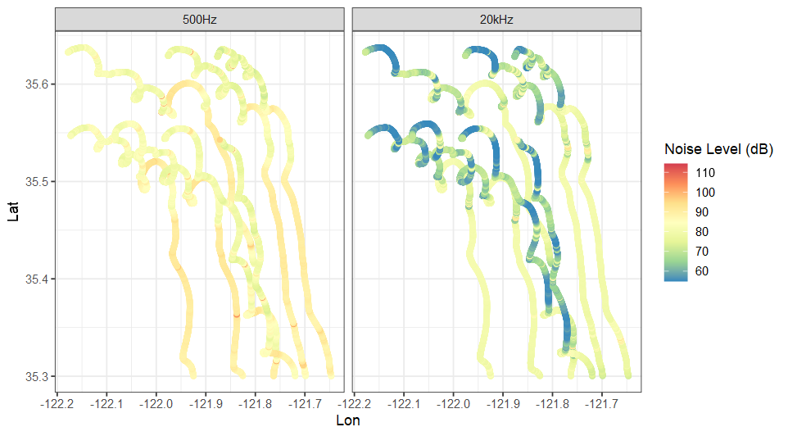Instruments drifted primarily southward with the prevailing currents with six of seven roughly maintaining their spacing throughout the deployment period. The Northeastern most drifter travelled further and faster than the remaining units. Median speed across all drifters was 0.15 m/s with a standard deviation of ±0.08 m/s. The distance travelled from deployment to recovery, ranged from 40.6 km to 66.8 km. The total distance travelled by each instrument throughout the deployment ranged from 61.9 km to 77.3 km for ADRIFT_53.

Figure 1 GPS tracks and aAverage 2-min Noise levels recorded by the seven drifters in the study in the lowest (500 Hz; left) and highest (20 khz; right) 1/3rd octave frequency bands.

* 1. Temporal Trends

Two storm events (atmospheric rivers) occurred during the second half of the deployment with the first starting on March 14th and second on the 15th. Noise levels in both 500 hz and 20 khz bins were elevated during these periods.

Figure 1shows the 2-minute median noise level in two third octave bins during an 8-day drift near the Morro Bay WEA. Increase in noise levels from two storms are march 14th and 15th that raised baseline noise levels approximately 10 and 20dB re 1µ Pa for the lower and upper third octave band respectively. Between the storms there was a period of increased variation in the 20khz bin. Visual inspection of this time period indicated the presence of persistent humpback whale song and dolphin whistles.

Figure 1 Two-minute timeseries of 1/3rd octave band levels for the 500 Hz and 20 kHz band. Black line indicates the 60-min rolling median noise level across all instruments.

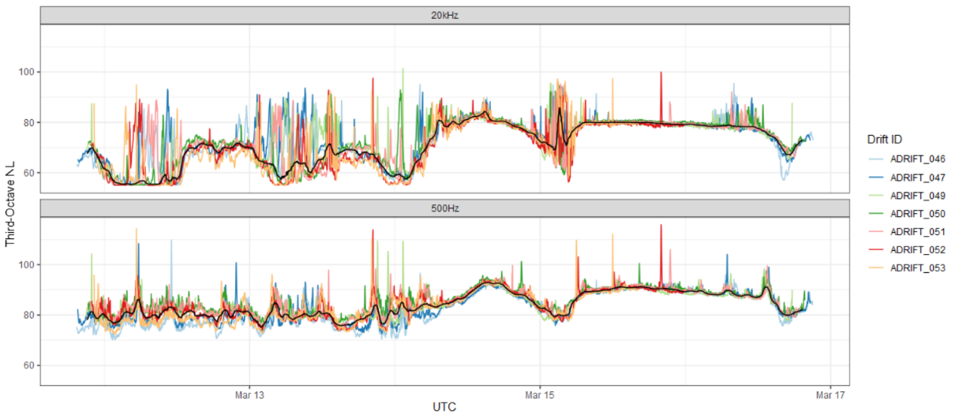

Correlations in raw noise levels between instruments were also high ranging from 0.64 to 0.83 in the 20 kHz band and 0.70 to 0.91 in the 500 Hz band (Figure). After normalization, these values were decreased to -0.16 to 0.46 in the 20 kHz band and -0.24-0.52 in the 500 Hz band.

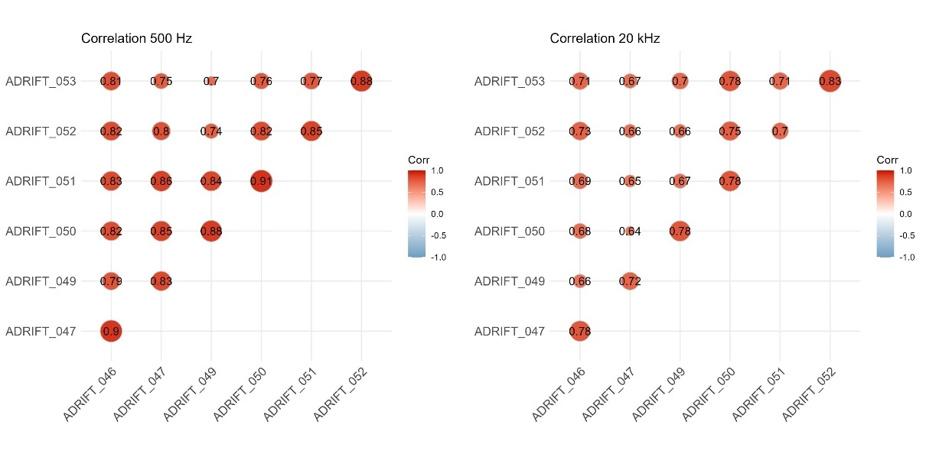

Figure 3 Raw collation scores between drifter data in the 500 hz (left) and 20 kHz (right) third-octave bins.

* 1. Spatial Trends

The best fitting model for the 20kHz model had 43 spline terms, a concordance value of 0.4372 and a marginal r6 value of 0.2797. Scaled Pearson’s residuals showed only minimal trend in relationship with the fitted values indicating that the model was reasonable estimate of the physical properties in the area. Variogram fitting resulted in estimated range parameter of 2531 m, beyond which variation in noise levels are not considered correlated. K-fold cross validation without replication resulted in average prediction error of 4.7 dB using this modelling approach.

The modelling approach for the high frequency data was much less successful. The best fitting model for the 500 Hz data had a concordance score of 0.1671 and a marginal r2 of 0.0912. Investigation of the scaled Pearson’s residuals indicated a linear decrease in the relationship between the observed and fitted values indicating that the estimation model was not a good representation of the underlaying processes. Average k-fold cross validation (n=5) prediction error for the high frequency model was 22.92 dB.

Figure 3 shows the predicted variation in ambient noise levels above the 90 min median for the 500 hz and 20khz Bands within the range estimates. Spatial patterns in variations. In the low frequency band, noise level trends over the survey period were lower northeast as compared to the northwest and southern part of the survey area. In contrast, high frequency predictions indicated two areas of high activity in the norther part of the study area and other areas of potential interest on the eastern part of the survey area. However, given the low value of the model and with consideration of edge effects, these values should be considered indicative at best.

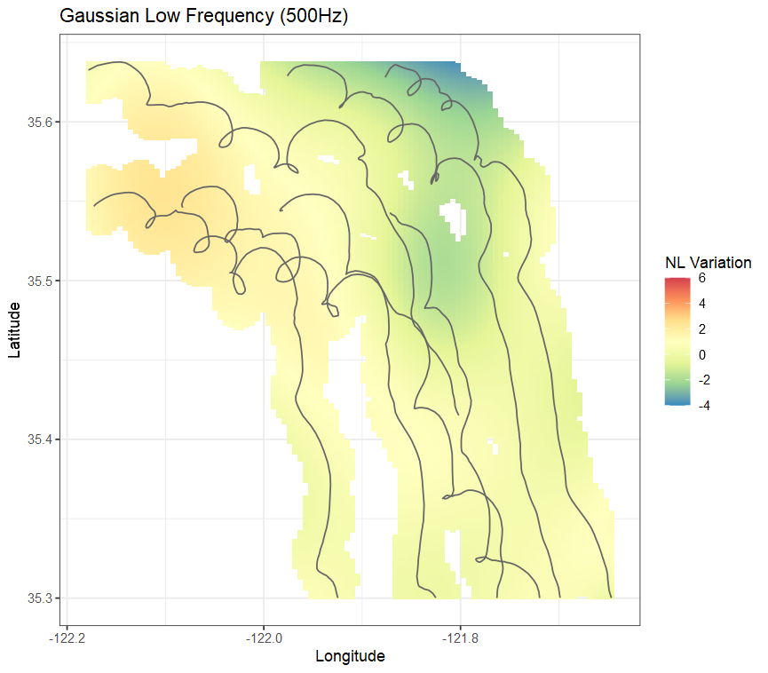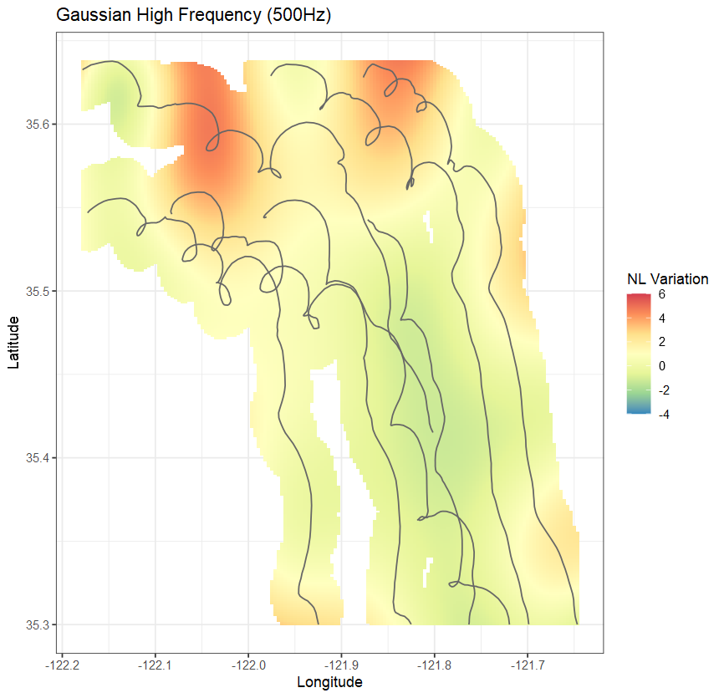

Figure 4 Predicted variation in noise levels across the study area and within the variogram estimated range of each of the sensors.

4 Discussion

Sound in the ocean is complex. The sound received at any given location is a combination of the physical environment as well the combination of the environmental, biological, and anthropogenic sound sources in the area. All such sources vary in time, frequency, and amplitude. Storm systems can raise noise levels across multiple frequency bands and can act over hundreds of kilometers. Similarly, in the shallow Alaskan North Slope, the reverberation from seismic air guns can raise the background sound levels over 100 km from the source (Guerra et al. 2013). In contrast, dolphin clicks and whistles are generally detectable out to XXX km.

The analysis presented here outlines some of the benefits and limitations of using a kriging smoothing approach with generalized estimating equations to evaluate spatial trends in sound. This approach worked reasonably well for the 500hz band and considerably less well in for the 20 kHz band. Causes for the poor model performance are well understood. First, the attenuation is greater for higher frequency sounds than lower. Second, and more important, in this case the 20khz band was dominated by wind/wave action and bioacoustics signals including dolphin whistles and humpback whale song. This was particularly true during the early hours of March 15th coinciding with the period of largest variation. The source levels from these animals and subsequent propagation distances of these sounds varies considerably. While it would be reasonable to expect humpback whale song to be detected by multiple instruments in the ensemble, the same is not the case for dolphin whistles. The combination of these disparate sources means that some signals will result in high concordance while others will not, lending to poor model fit. Thus, future studies seeking to use these methodologies should take this into consideration if they are seeking to map higher frequency components, a smaller aperture array is required. In contrast if the primary goal of the deployment is to investigate concordance among low (<1khz) sounds, a larger aperture ensemble may justified.

It is also worth nothing that there was little vessel activity noted on either deployment or recovery days and given the offshore sea conditions during the deployment, it is unlikely that vessel activity dominated the local soundscape. Investigation of the LTSAs did indicate the presence of ship noise across many of the instruments but vessel noise was not otherwise common in these data.

Variogram range estimates were similar between both frequency bands and lower than would be expected for the low-frequency analysis. This is because the study sought to investigate spatial variation within the survey area. Doing so required removing the dominant signals acting across the array which would have had higher concordance values. The remaining signals were those that differed from the average background noise and, by definition, ensonified smaller regions of the study area.

The variability in concordance between different sources, again, points to the value in of considering aperture spacing, as much as is possible in the California Current and carefully considering the scope of the analysis. In this case data were collected as part of exploratory surveys of an offshore wind lease area. The overarching goals were to 1) measure soundscapes in the wind lease area 2) evaluate the presence of cetaceans in the habitat. As such, an initial ensemble spacing of 5km was chosen to maximize spatial coverage while trying to maintain the recoverability of the drifting buoys. Increasing the array spacing would have allowed for a better understanding of the spatial extent of low frequency noise without the need to normalize the recorded levels. Conversely a more directed survey with smaller >1km spacing would have allowed for detailed high frequency analysis over a smaller area.

This work highlights some of the inherent values of using multiple drifting sensors as compliments to bottom-moored arrays. These instruments are much more orders of magnitude more affordable than other offshore equipment and can be deployed in a variety of configurations. Because the units drift with the prevailing currents they are also capable of covering large distances at a fraction of the expense of towed arrays and without the noise of the towing vessel.

As offshore wind construction begins on the US West coast, there will be a need to study the impacts of construction on marine life. The most popular methodology for large scale studies of ambient noise levels within restricted region involves combining AIS ship density with propagation models in order to estimate sound levels on larger scales. These are usually validated with single bottom moored single sensors (Joy et al. 2017, Farcas et al. 2020). When applied for sound management these approaches are best used when the validating hydrophone occupies the same habitat as the species of interest.

1. Conclusion

In conclusion, this study demonstrates the feasibility of using drifting acoustic recorders to monitor ambient noise levels in offshore wind energy areas. The results highlight the complexity of ambient noise dynamics and the challenges in modeling high-frequency noise sources. Despite these challenges, drifting sensors offer valuable insights into spatial and temporal variations in noise levels, complementing long-term studies using fixed sensors.

Supplementary Material

All data and models are available on github

Acknowledgments

This work was supported by…

The Fulmar crew

The whale watch crew

Author Declarations

Conflict of Interest

A conflict-of-interest statement is required. If there are no conflicts to report, the authors must state that they have no conflicts to disclose.

Ethics Approval

Data Availability

A data availability statement is required. For the *Journal'*s data policy and suggested templates, please see the Information for Contributors: <https://pubs.aip.org/asa/jel/pages/manuscript>.

References and Links (BIBLIOGRAPHIC STYLE)

Cholewiak, D., C. W. Clark, D. Ponirakis, A. Frankel, L. T. Hatch, D. Risch, J. E. Stanistreet, M. Thompson, E. Vu, and S. M. Van Parijs (2018). Communicating amidst the noise: Modeling the aggregate influence of ambient and vessel noise on baleen whale communication space in a national marine sanctuary. Endangered Species Research 36:59–75.

Farcas, A., Powell, C.F., Brookes, K.L. and Merchant, N.D., 2020. Validated shipping noise maps of the Northeast Atlantic. Science of the Total Environment, 735, p.139509.

Gabriele, C. M., D. W. Ponirakis, C. W. Clark, J. N. Womble, and P. Vanselow (2018). Underwater acoustic ecology metrics in an Alaska marine protected area reveal marine mammal communication masking and management alternatives. Frontiers in Marine Science 5:270.

Guerra, M., Thode, A.M., Blackwell, S.B. and Michael Macrander, A., 2011. Quantifying seismic survey reverberation off the Alaskan North Slope. The Journal of the Acoustical Society of America, 130(5), pp.3046-3058.

Joy, R., Tollit, D., Wood, J., MacGillivray, A., Li, Z., Trounce, K. and Robinson, O., 2019. Potential benefits of vessel slowdowns on endangered southern resident killer whales. Frontiers in Marine Science, 6, p.344.

Oedekoven, Cornelia S., Tiago A. Marques, Danielle Harris, Len Thomas, Aaron M. Thode, Susanna B. Blackwell, Alexander S. Conrad, and Katherine H. Kim. "A comparison of three methods for estimating call densities of migrating bowhead whales using passive acoustic monitoring."Environmental and Ecological Statistics 29, no. 1 (2022): 101-125. https://doi.org/10.1007/s10651-021-00506-3

K. J. Palmer, Gi-Mick Wu, Christopher Clark, Holger Klinck; Accounting for the Lombard effect in estimating the probability of detection in passive acoustic surveys: Applications for single sensor mitigation and monitoring. J. Acoust. Soc. Am. 1 January 2022; 151 (1): 67–79. <https://doi.org/10.1121/10.0009168>

Merchant, N.D., Pirotta, E., Barton, T.R. and Thompson, P.M., 2014. Monitoring ship noise to assess the impact of coastal developments on marine mammals. Marine Pollution Bulletin, 78(1-2), pp.85-95.

Scott-Hayward, L.A.S., Mackenzie, M.L., Oedekoven, C.S. and Walker, C.G., 2014. Modelling impact assessment in renewables development areas using the new R package, MRSea v0. 1.1. Proc. EIMR, pp.2014-596.

Walker, C.G., Mackenzie, M.L., Donovan, C.R. and O'sullivan, M.J., 2011. SALSA–a spatially adaptive local smoothing algorithm. Journal of Statistical Computation and Simulation, 81(2), pp.179-191.

ZoBell, V.M., Hildebrand, J.A. and Frasier, K.E., 2024. Comparing pre-industrial and modern ocean noise levels in the Santa Barbara Channel. Marine Pollution Bulletin, 202, p.116379.

1. a Author to whom correspondence should be addressed.